STUDENT CENTRIC TEACHING METHODS
- Field based Assessment

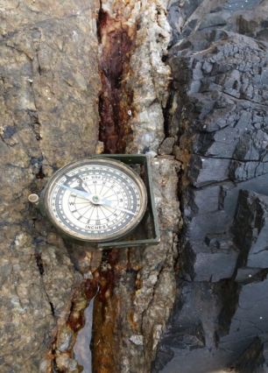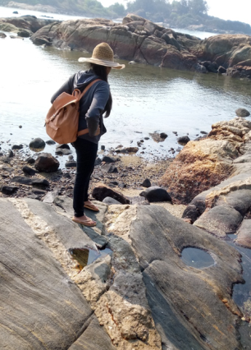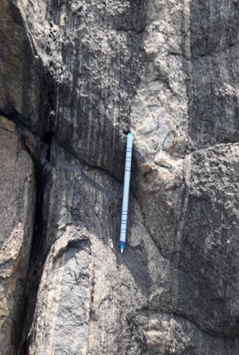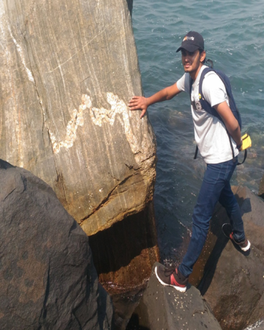

- Flipped classroom
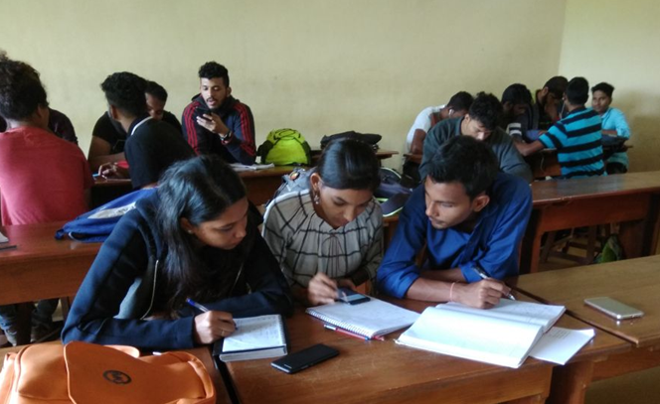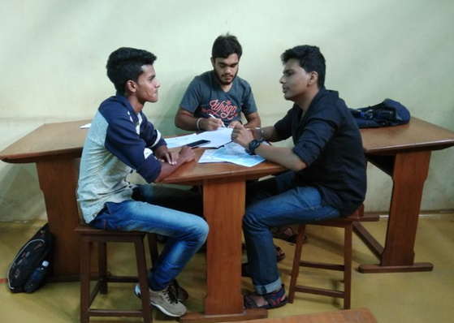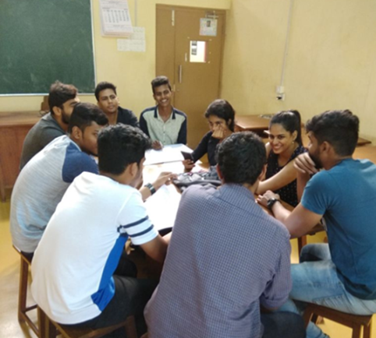
Team-Pair Solo Three-Step Interview Round Robin

- Uploading videos on YouTube and use of Edpuzzle.com
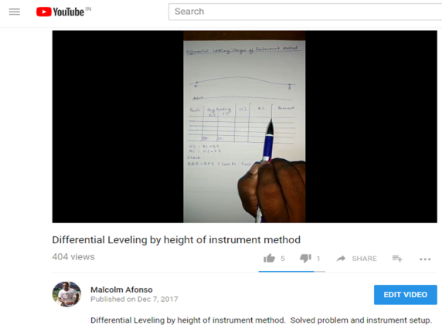
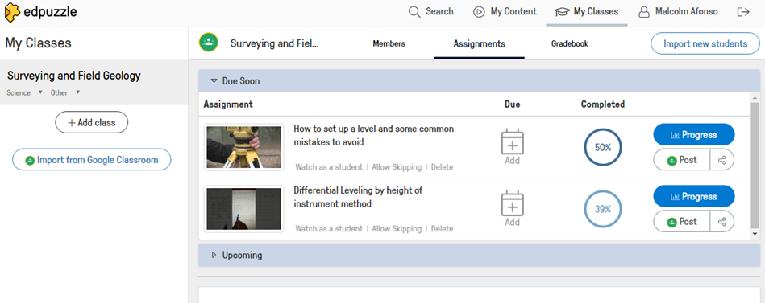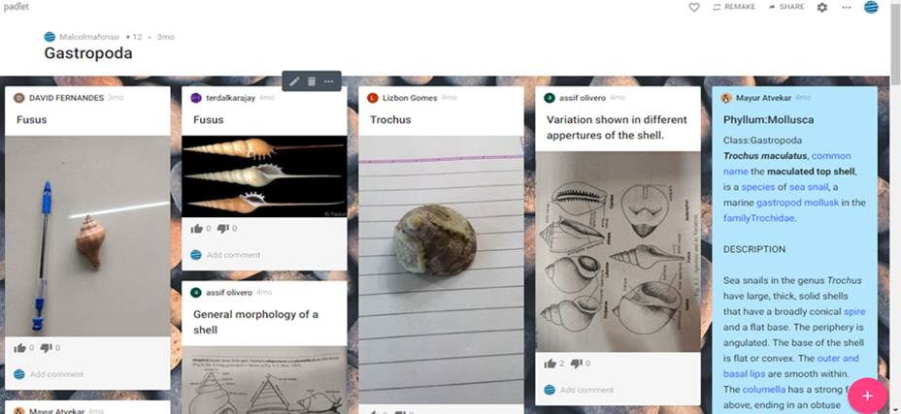

- Teaching with Google Earth

Google Earth is a free, downloadable application that works as a browser for all sorts of information on Earth. Google Earth provides an immersive and interactive experience for students to learn about our earth. We have used Google earth platform to cover the topic ‘’Morphology of the ocean floor’’ for the students of Marine Geology Course.
Methodology
Google earth platform was used to study the bathymetry of the ocean floor. The imagery provided insights into the shape, size and features present in the ocean basins, the locations of various ocean features such as mid-ocean ridges, seamounts, locations of hotspots, trenches, ocean islands, and volcanic arcs were very apparent in the imagery provided by Google earth.

Vector Layers of earth surface model, plate boundaries, recent earthquakes, volcanoes in KML format were then overlaid on base map to study relationships of these ocean features to their tectonic settings.
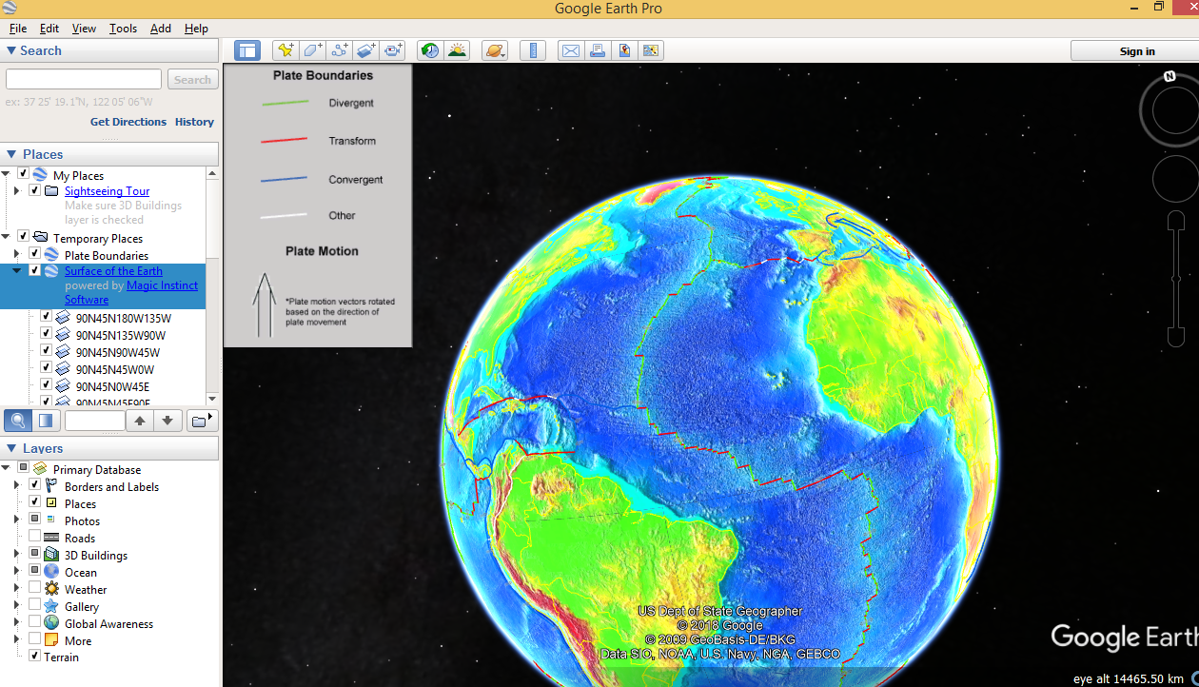
Figure 1: Mid-Ocean ridges. Earth surface model and plate boundary kml overlaid on Google earth depicting plate boundaries and their relation to ocean features

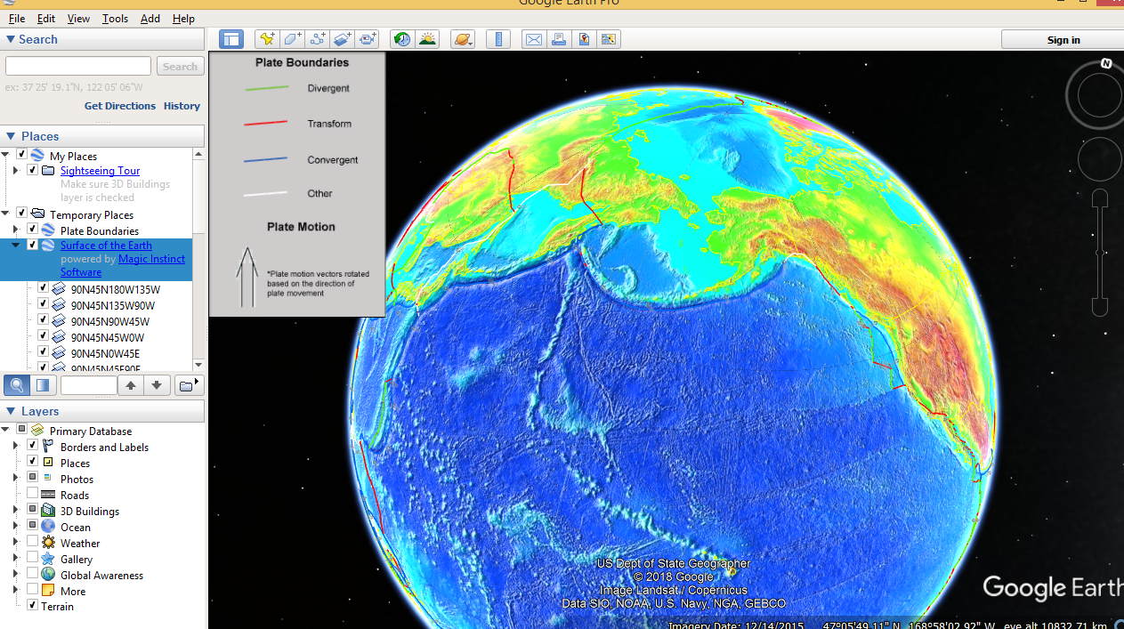
Figure 2: Linear chain of ocean islands and Volcanic arc. Earth surface model and plate boundary kml overlaid on Google earth depicting plate boundaries and their relation to ocean features

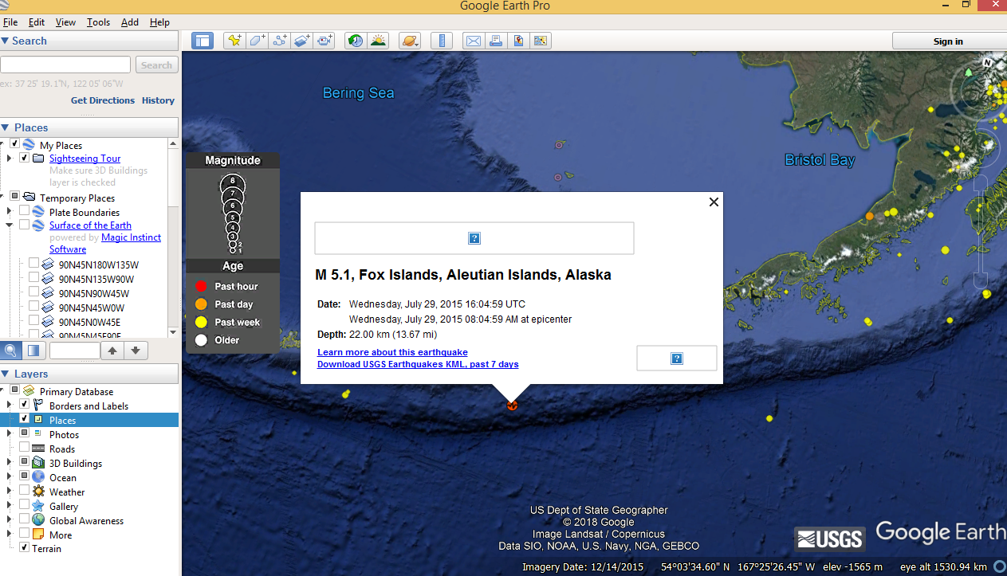
Figure 3: Imagery showing the location of epicentre of latest earthquake, kml updated by USGS.

